--- E2E Flow ---

**Auctioneer - Add Item for Auction**

1. Register Auctioneer   
   A screenshot of a computer

   Description automatically generated
2. Login as Auctioneer

1. Add item for Auction  
     
   A screenshot of a computer

   Description automatically generated

Participant Flow

1. Register Participant

1. Login as Participant

1. Get Auction

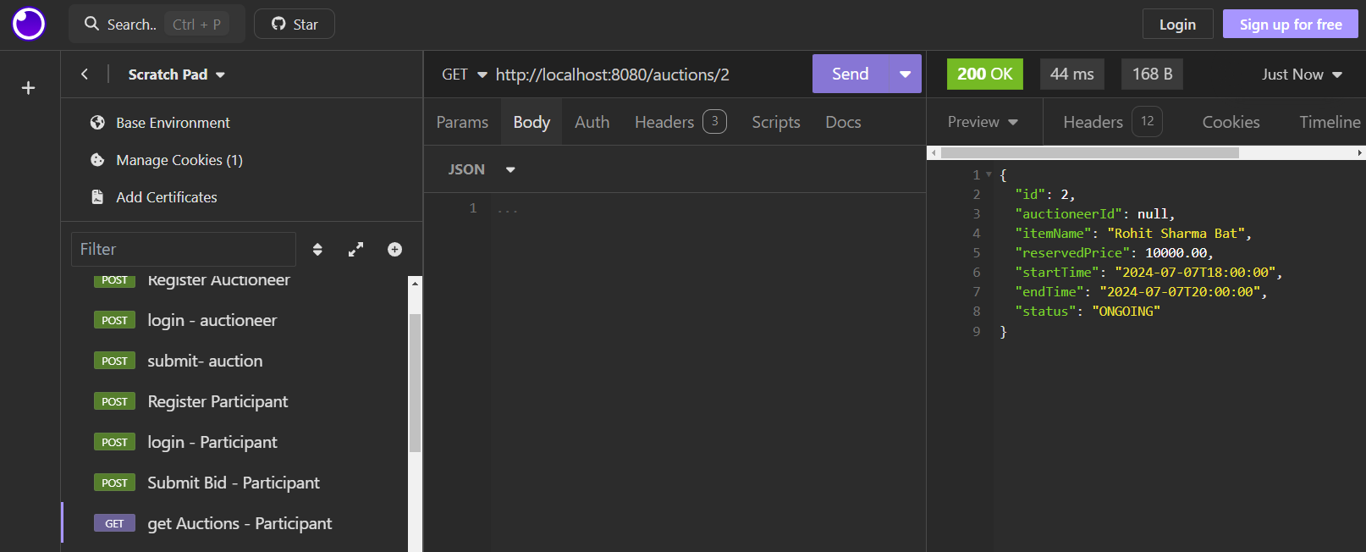

1. Submit a Bid (Positive)

1. Submit a Bid (Negative – As Highest bid amount is 11000)

====================================

Get Auction Status

- Auctioneer can see the status of bidding – Ongoing

=====================================

Get Highest Bid

- Auctioneer can see the highest Bid value

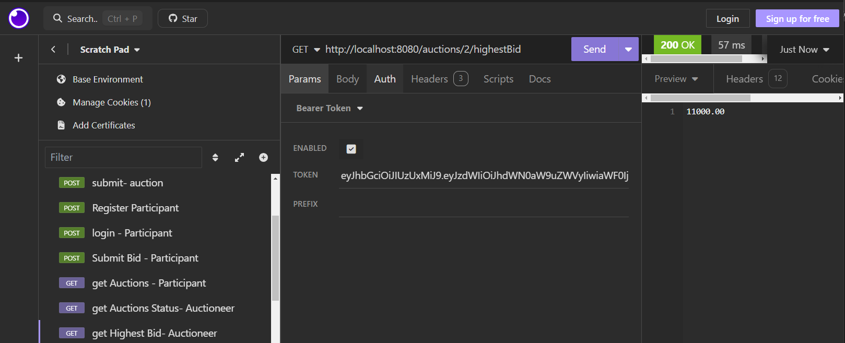

=================================

Admin Flow

1. Register as Admin

1. Login as Admin

1. Generate Report   
     
   A screenshot of a computer

   Description automatically generated